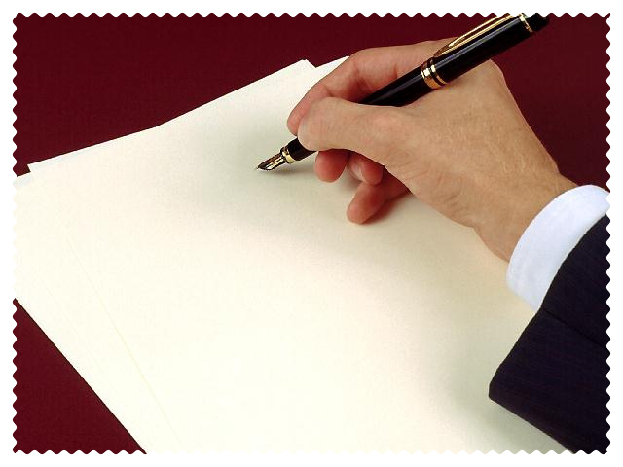

The Business

Letter

Writing a letter properly is very important. There are two general types of letters. There is the business letter and the personal letter. We will look at these respectively.
(The following outline is from Webster’s Home & Office Desk Reference.)

- THE BUSINESS LETTER

A. The Business Letter as an Image-Maker

B. Letter Balance and Letterhead Design

C. Choosing the Right Paper

D. General Punctuation Patterns in Business Correspondence

E. The Individual Parts of a Business Letter

F. Letter Styles for Business Correspondence

Style in business correspondence, like language itself, is not a static entity. It has changed over the years to meet the varying needs of its users, and it continues to do so. For example, the open-punctuation pattern and the Simplified letter have recently gained wide popularity, while the closed-punctuation pattern and the Indented Letter, once considered standard formats, are now used very little in the United States. In many cases, the choices and alternatives to style are only a matter of individual taste; writers will have to use their own judgment to choose among the acceptable styles.

Illustration:
1
2
3
<<Street Address>>
<<City, State, Zip Code>>
<<Date>>

<<Greeting>>,

<<Body>>

<<Closing>>
<<Signature>>

4

df

